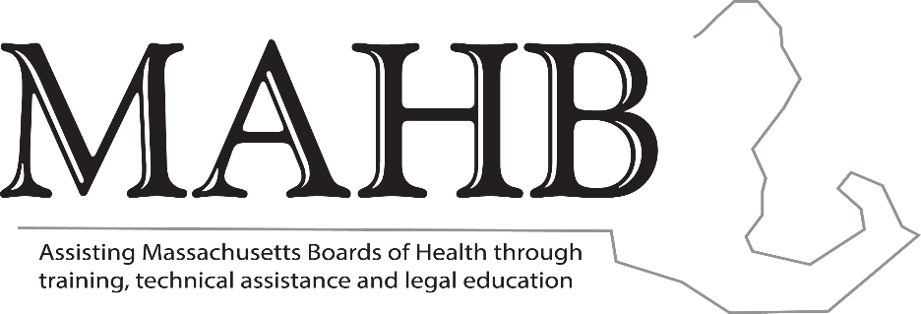

MASSACHUSETTS ASSOCIATION OF HEALTH BOARDS

Executive Board Meeting
10.6.22 - 5:30 pm
Four Points Sheraton - Norwood

Agenda

- AAFCPA’s Report – Amy Staunton, CPA
- Certificate Programs – after action report – Cheryl Sbarra, JD
- Update on future trainings – Cheryl Sbarra, JD
  - Scheduled webinar
  - State Ethics Commission
  - Monthly webinars
- Bylaw Subcommittee Report
- SAPHE 2.0 update – Mike Hugo, JD
- Legislative Update – Mike Hugo, JD
- Grants update
  - MTCP (MAHB 01) – Cheryl Sbarra, JD
  - Legal TA (MAHB 07) – Cheryl Sbarra, JD
  - Mini Grant (MAHB-03) – Cheryl Sbarra, JD
  - HMCC – Elaine LaCoursiere

