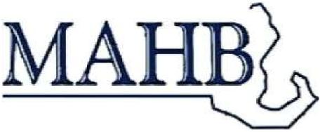
Massachusetts Association of Health Boards
56 Taunton St.
Plainville, MA 02762
Phone & Fax (508) 643-0234 email benes@mahb.org
MAHB Certificate Program Invoice
Blue Bonnet Diner Northampton MA
October 5, 2019
TAX NUMBER 04-2774252
[ ] registrations @ $20 each for MAHB members
[ ] registrations @ $30 each for non MAHB members
City/Town____________________________zip_______________ Please provide names of each registrant, along with an email address This information will be used to print the certificates, so please use the name that registrants will want to appear on the certificate.
Name____________________________________ email____________________________________
Name ____________________________________ email____________________________________
Name____________________________________ email____________________________________
Name____________________________________ email____________________________________
Name____________________________________ email____________________________
Checks should be payable to MAHB, 56 Taunton St. Plainville MA 02762

