Flavored Tobacco Product Restriction

The XXX board of health has passed a Flavored Tobacco Product Restriction. Here are answers to questions you may have:

What is the new regulation on flavored tobacco products?
- No retailer can sell a flavored tobacco product unless the flavor is mint or menthol.
- The regulation does not apply if you are an adult-only Retail Tobacco Store or Smoking Bar. Read the regulation or call the XXX board of health to see if you qualify for either of these two exemptions.
- The penalties for violating this regulation are: [NOTE: your local regulation might have a different penalty structure.]
1st violation = $100
2nd violation = $200 and a 7-day suspension
3rd+ violation = $300 and a 30-day suspension

Why was this regulation passed?
This regulation was passed to address youth use and exposure to flavored tobacco products. The tobacco industry has used attractive flavors and bold packaging to target young people. Reducing youth exposure to these products will counteract this targeting.

What products are covered by this regulation?
Flavored cigars, little cigars, chewing tobacco, pipe tobacco, snuff, shisha, blunt wraps, electronic cigarettes (e-cigarettes), electronic cigars, electronic pipes, electronic hookah, “e-juices” and other similar products that are not mint or menthol. (Note: Flavored cigarettes that are not menthol have been prohibited by Federal law since 2009).

What does it mean for a product to be flavored?
A product is flavored if it has a taste or smell relating to any fruit, chocolate, vanilla, honey, candy, cocoa, dessert, alcoholic beverage (cognac, rum), herb or spice (clove).

May I continue to sell menthol and mint flavored products?
Yes. Those products are excluded from this regulation.

If a product label does not say the product is flavored, does that mean it is ok to sell?
Maybe not. Some products do not list the flavor on the package, but still are flavored. The chart on the next page gives examples.

Product Name | Photo | Does the product label indicate it has a flavor? | May I sell? | Why/Why not?
Game Pineapple Cigarillo | 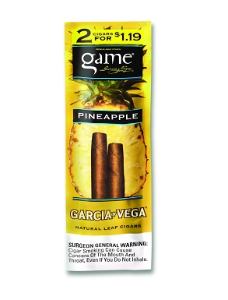 | Yes | No | Has a taste or aroma other than mint, menthol or tobacco
Game Red Cigar | 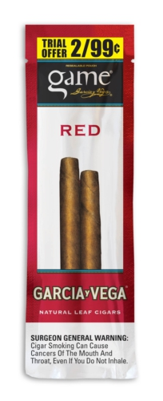 | No | No | Has a taste or aroma other than mint, menthol or tobacco
Black & Mild Jazz cigarillos | 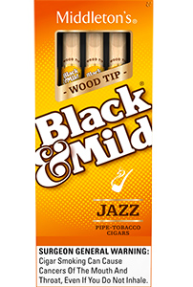 | No | No | Has a taste or aroma other than mint, menthol or tobacco
Black & Mild Mild cigarillos | 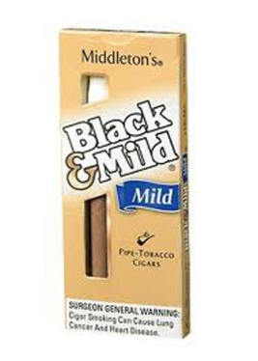 | No | Yes | Does not have a taste or aroma other than mint, menthol or tobacco

How do I know if a product is flavored?
Your distributor can tell you. Tell them that you must follow this regulation and that you may not sell any flavored products other than mint or menthol. If they are unsure about a product, ask them to get this information from the manufacturer.
Is there a list of flavored tobacco products I cannot sell?
Attached is the flavored product list that the XXX board of health has adopted to help everyone understand the flavored product regulation. The list will be posted on the XXX board of health website and you will be notified when new products are added and the list is updated. However, this list is not exhaustive and does not include every flavored product on the market. This means that a fine could be issued for a product that is not on this list if the board of health determines it is a flavored product.
What if I want to sell a product that is not on this list, but I’m not sure if it is flavored?
Ask your distributor if the product is flavored. If they do not know, or you still think it may be flavored, contact the XXX board of health at [PHONE NUMBER] or [EMAIL]. New products and products that are not on the flavored product list can still be a violation of the flavored tobacco product regulation. Before you buy the product from your distributor, you may want to contact the board of health to confirm that the product will not be in violation of the regulation.

